

Data Structures and Algorithms -23CSE203

Lab Manual

Submitted By

NAME | T.Naga Siddhardha
ROLL NO | AV.SC.U4CSE25151
YEAR/SEM/SECTION | 2nd YEAR/ SEM-3/CSE-B
CREDITS | 05

Submitted to
NAME | DR. RAJ KUMAR BATCHU
DESIGNATION | ASST.PROFFESSOR (Sl. Grade)
DEPARTMENT | SCHOOL OF COMPUTING

Index
week |  | Page-numbers
1 | - A rocket launch system displays a count down before launch. Instead of using a loop, implement the count down using recursion. Write a recursive python program to display countdown from n to 1 followed by launch.  - Banks calculate the growth of investment using compound interest. The formula requires calculating powers, which can be implemented recursively. Write a recursive program to calculate P^n where P = Principal growth factor, n = number of years  - A HR department stores employee details in a list. Develop a recursive program to search for a given employee ID. Write a recursive function to search for an employee ID in a list.  - In a logistic department, the no of possible ways to arrange n diff parcels are calculated using the factorial formula(n!). Write a recursive formula to find the factorial of a given number  - Print first n terms in a fibanocci number series
2 | - Write the implementation for the linear search algorithm  - Write the implementation for the binary search algorithm  - Write the implementation for the binary search algorithm along with the sorting the input elements if they are not sorted.
3 | - Write a python program to implement bubble sort where the input elements are taken from the user.  - Write a python program to implement insertion sort where the input elements are taken from the user.  - Write a python program to implement selection sort where the input elements are taken from the user.
4 | - Write a python program to implement merge sort where the input elements are taken from the user  - Write a python program to implement quick sort where the input elements are taken from the user
6. | - Write a python program to implement the stack operations such as push, pop, peek, display using array, linked list

Week-1
- A rocket launch system displays a count down before launch. Instead of using a loop, implement the count down using recursion. Write a recursive python program to display countdown from n to 1 followed by launch.
Input:
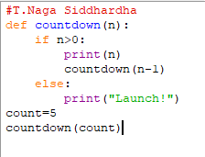
OUTPUT:
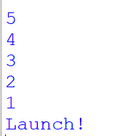
Explanation:
The program uses recursion to display the countdown from n to 1. The function calls itself with n-1 until n becomes 0. After reaching the base condition, it displays "Launch!". This performs the countdown without using a loop.
- Banks calculate the growth of investment using compound interest. The formula requires calculating powers, which can be implemented recursively. Write a recursive program to calculate P^n where P = Principal growth factor, n = number of years
Input:
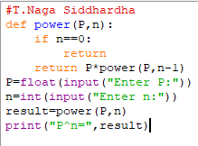
Output:
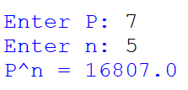
Explanation:
The recursive function power() calculates by multiplying P with . The recursion stops when n becomes 0, where the result is 1.
- A HR department stores employee details in a list. Develop a recursive program to search for a given employee ID. Write a recursive function to search for an employee ID in a list.
Input:
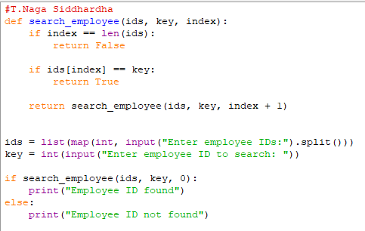
Output:
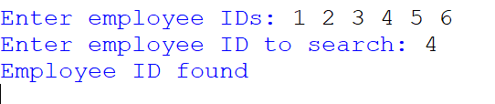
Explanation:
The function checks each employee ID recursively. If the ID matches the given ID, it returns True. If the end of the list is reached without a match, it returns False.
- In a logistic department, the no of possible ways to arrange n diff parcels are calculated using the factorial formula(n!). Write a recursive formula to find the factorial of a given number
Input:
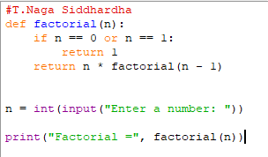
Output:
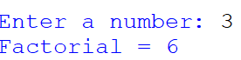
Explanation:
The recursive function factorial() calculates by multiplying n with the factorial of n-1. The recursion stops when n becomes 0 or 1.
- Print first n terms in a fibanocci number series
Input:
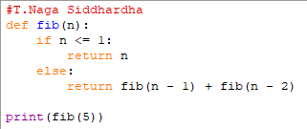
Output:
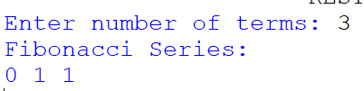
Explanation:
The recursive function fibonacci() returns the sum of the previous two Fibonacci terms. The first two terms are 0 and 1. The program calls the function for each term from 0 to n-1.

WEEK-2
- Write the implementation for the linear search algorithm
INPUT:
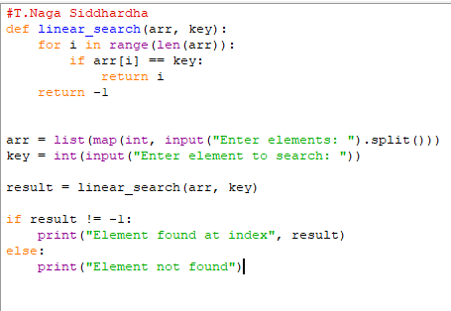
OUTPUT:
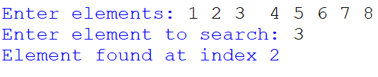
EXPLANATION:
Linear search checks each element one by one from the beginning of the list until the required element is found or the list ends.

- Write the implementation for the binary search algorithm
INPUT:
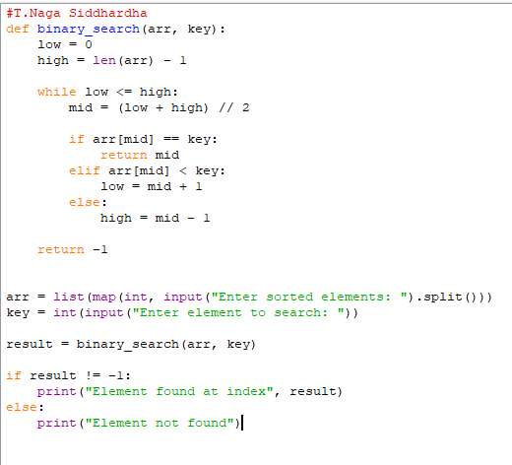
OUTPUT:
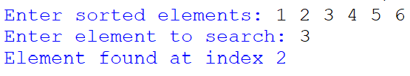
EXPLANATION:
Binary search works only on a sorted list. The program first sorts the input elements using sort(). It then repeatedly checks the middle element and eliminates half of the search range until the element is found or the range becomes empty.

WEEK-3
- Write a python program to implement bubble sort where the input elements are taken from the user.
Input:
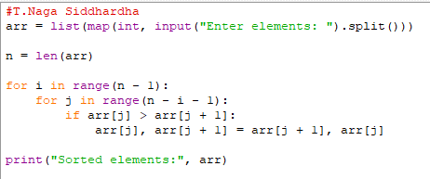
Output:
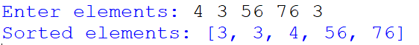
Explanation:
Bubble sort repeatedly compares adjacent elements and swaps them if they are in the wrong order. After each pass, the largest unsorted element moves to its correct position.

- Write a python program to implement insertion sort where the input elements are taken from the user.
Input:
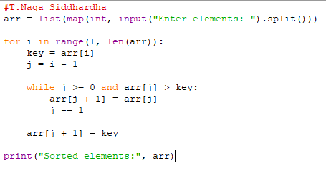
Output:
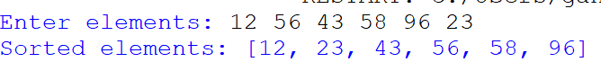
Explanation:
Insertion sort takes one element at a time and inserts it into its correct position among the already sorted elements.

C) Write a python program to implement selection sort where the input elements are taken from the user.
Input:
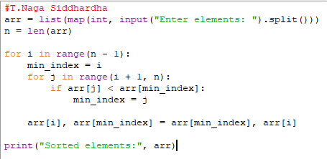
Output:
Explantion:
Selection sort finds the smallest element from the unsorted portion and swaps it with the first element of that portion. This process continues until the entire list is sorted.

Week – 4
4a)
Aim:
Write a python program to implement merge sort where the input elements are taken from the user
Code:
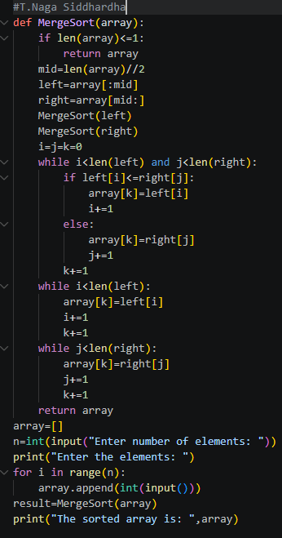

Output:
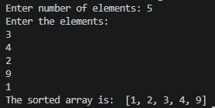
Error Table:
Error | Rectification
RecursionError: maximum recursion depth exceeded | base case in merge_sort() len(arr) <1 to len(arr) <= 1
PS C:\Users\Lab\Documents\cse25142\dsa-lab\week-4> python merge_sort.py  [2, 3, 7, 7, 8, 3, 7, 7, 8, 7, 7, 8] | kept the extend in the while loop instead of out of while loop
Description:
- The program implements the Merge Sort algorithm.
- The user enters the size of the array.
- The elements are taken from the user and stored in a list.
- The merge_sort() function recursively divides the array into two halves.
- The array is divided until each sub-array contains one or zero elements.
- The left and right portions are then sorted recursively.
- The sorted left and right arrays are compared element by element.
- The smaller element is placed into the original array.
- Remaining elements from either portion are then copied into the array.
- Finally, the completely sorted array is displayed.
- Merge Sort follows the divide-and-conquer approach.

4b)
Aim:
Write a python program to implement quick sort where the input elements are taken from the user.
Code:
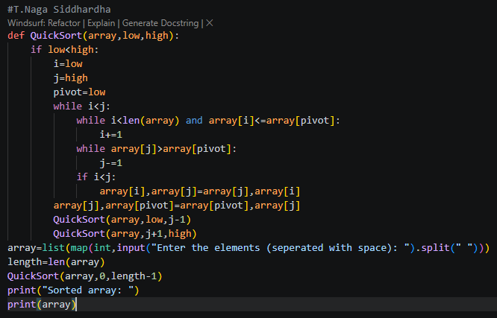
Output:
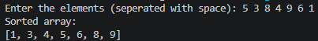
Error Table:
Error | Rectification
PS C:\Users\Lab\Documents\cse25142\dsa-lab\week-4> python quick_sort.py  rolln0 : cse25142  name : P. Bhanu Kiran  Enter size of array: 7  enter 1 element: 2  enter 2 element: 3  enter 3 element: 56  enter 4 element: 9  enter 5 element: -`  enter 6 element:  enter 7 element: 2 | Instead of inputting the integers, inputted the string added int before the input  arr.append(int(input(f”enter {i+1} element”)
PS C:\Users\Lab\Documents\cse25142\dsa-lab\week-4> python quick_sort.py  Traceback (most recent call last):  File "C:\Users\Lab\Documents\cse25142\dsa-lab\week-4\quick_sort.py", line 24, in <module>  main()  File "C:\Users\Lab\Documents\cse25142\dsa-lab\week-4\quick_sort.py", line 5, in main  quick_sort(arr)  TypeError: quick_sort() missing 2 required positional arguments: 'low' and 'high'  PS C:\Users\Lab\Documents\cse25142\dsa-lab\week-4> | added the two parameters to the function
Traceback (most recent call last):  File "C:\Users\Lab\Documents\cse25142\dsa-lab\week-4\quick_sort.py", line 29, in <module>  main()  File "C:\Users\Lab\Documents\cse25142\dsa-lab\week-4\quick_sort.py", line 9, in main  print(quick_sort(arr, 0, n-1))  ^^^^^^^^^^^^^^^^^^^^^^^  File "C:\Users\Lab\Documents\cse25142\dsa-lab\week-4\quick_sort.py", line 26, in quick_sort  quick_sort(a, j+1, high) #right part  ^^^^^^^^^^^^^^^^^^^^^^^^  File "C:\Users\Lab\Documents\cse25142\dsa-lab\week-4\quick_sort.py", line 24, in quick_sort  a[j], a[pivot] = a[pivot] = a[j] # placing the pivot in the correct position  ^^^^^^^^^^^^^^  ValueError: too many values to unpack (expected 2) | Placed a comma
Description:
- The program implements the Quick Sort algorithm.
- The user enters the size of the array.
- The elements are taken from the user and stored in a list.
- The quick_sort() function is used to sort the array recursively.
- The first element of the current portion is selected as the pivot.
- Two pointers, i and j, are used to compare elements with the pivot.
- i moves from the left side and searches for an element greater than or equal to the pivot.
- j moves from the right side and searches for an element smaller than or equal to the pivot.
- If i < j, the two elements are swapped.
- After the partitioning process, the pivot is placed in its correct position.
- The array is then divided into left and right portions.
- Quick Sort is recursively applied to both portions.
- Finally, the sorted array is printed.

Week – 5
5a)
Aim:
Write a Python program to implement a Singly Linked List (SLL) with the following operations:
1. Create LL
2. Insert at Beginning
3. Insert at End
4. Insert at Index
5. Delete by Value
6. Delete Prior Node
7. Delete Last Node
8. Count Number of Nodes
9. Display/Traverse
10. Exit

Code:
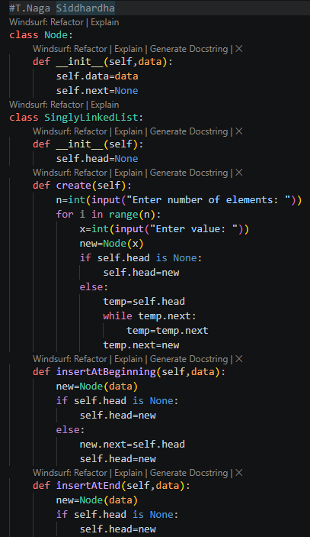
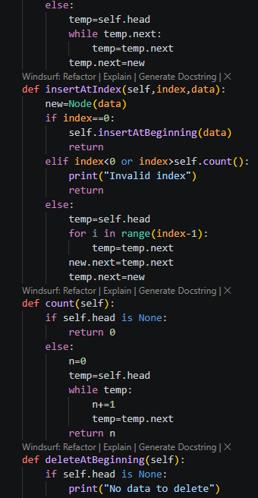
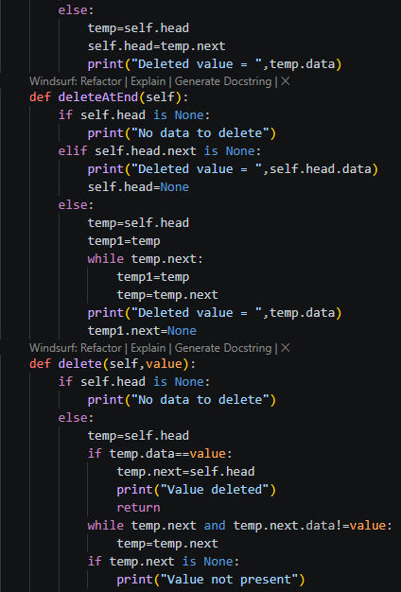
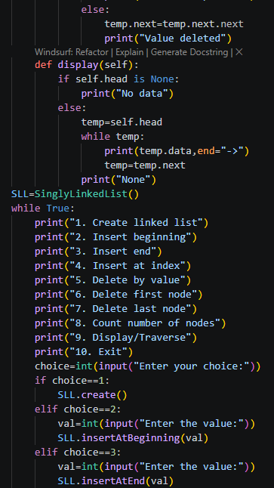
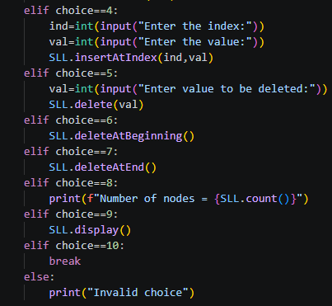
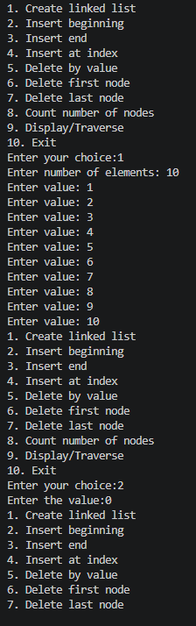
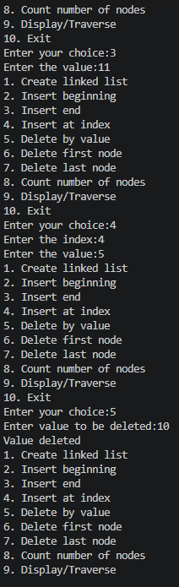
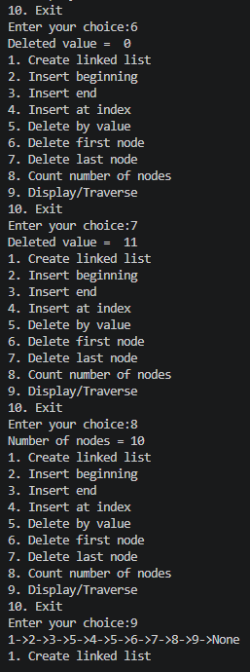
Error Table:
Error | Rectification
The program may display an incorrect message for insertion at a specific index even when the index is invalid | Check whether the index is valid before displaying the successful insertion message.
Description:
- The program implements a Singly Linked List using Python classes.
- The Node class is used to create individual nodes.
- Each node contains two parts: data and next.
- data stores the value of the node.
- next stores the reference to the next node.
- The SingleLinkedList class manages the linked list.
- The head variable stores the reference to the first node.
- The program provides an option to create a linked list.
- It supports insertion at the beginning of the list.
- It supports insertion at the end of the list.
- It supports insertion at a specific index.
- It supports deletion of a specific value.
- It supports deletion of the first node.
- It supports deletion of the last node.
- It provides a function to count the number of nodes.
- It provides a function to display/traverse all the nodes.
- A menu-driven approach is used to allow the user to select different operations.
- The program continues running until the user selects the Exit option

5b)
Aim:
Write a Python program to implement a Double Linked List (DLL) with the following operations:
1. Create LL
2. Insert at Beginning
3. Insert at End
4. Insert at Index
5. Delete by Value
6. Delete Prior Node
7. Delete Last Node
8. Count Number of Nodes
9. Display/Traverse
10. Exit
Code:
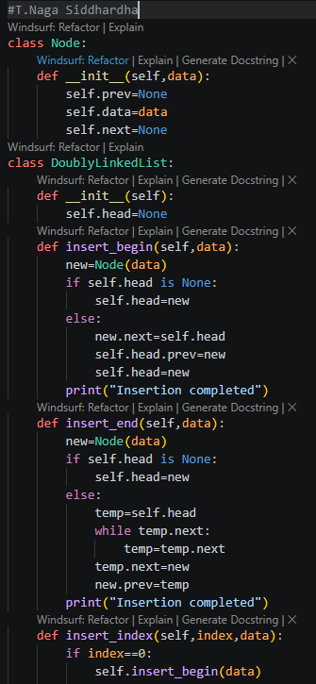
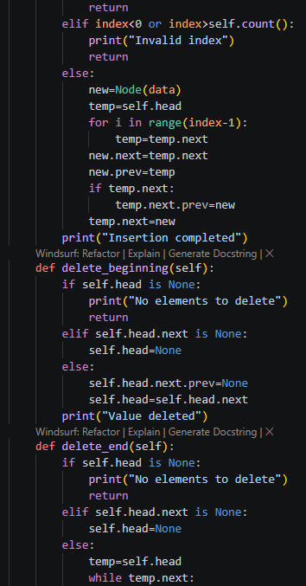
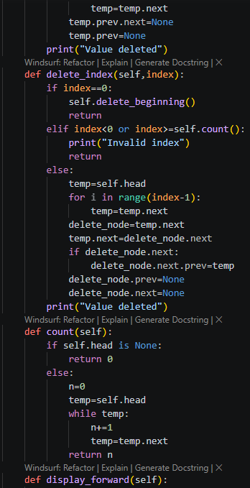
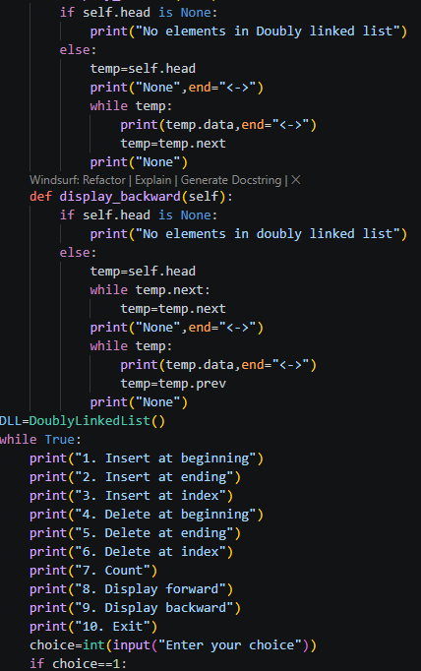
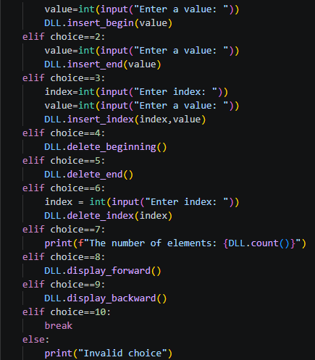
Output:
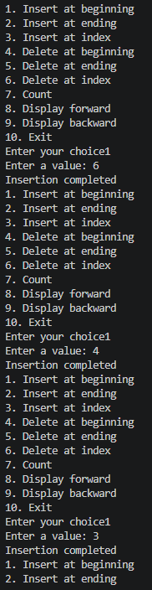
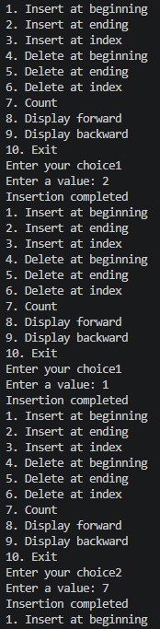
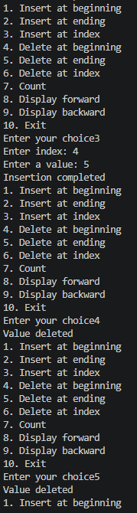
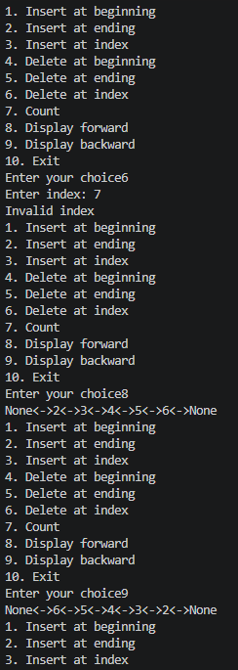
Error Table:
Error | Rectification
The prev and next links may not be updated correctly during insertion or deletion. | Update both links whenever a node is inserted or deleted.
Description:
- The program implements a Doubly Linked List using Python classes.
- The Node class is used to create individual nodes.
- Each node contains three parts: data, prev, and next.
- data stores the value of the node.
- prev stores the reference to the previous node.
- next stores the reference to the next node.
- The DoubleLinkedList class is used to manage the linked list.
- The head variable stores the reference to the first node.
- The program provides an option to create a doubly linked list.
- It supports insertion at the beginning of the list.
- It supports insertion at the end of the list.
- It supports insertion at a specific index.
- It supports deletion of a specific value.
- It supports deletion of the first node.
- It supports deletion of the last node.
- It provides a function to count the number of nodes.
- It provides a function to display/traverse the list.
- During insertion and deletion, both prev and next links are updated.
- The list is displayed using <--> to show the connection between nodes.
- A menu-driven approach is used to perform different DLL operations.
- The program continues until the user selects the Exit option.

5c)
Aim:
Write a Python program to implement a Circular Linked List (CLL) with the following operations:
1. Create LL
2. Insert at Beginning
3. Insert at End
4. Insert at Index
5. Delete by Value
6. Delete Prior Node
7. Delete Last Node
8. Count Number of Nodes
9. Display/Traverse
10. Exit

Code:
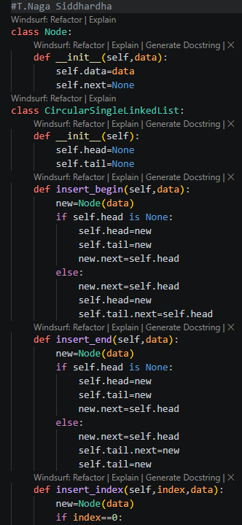
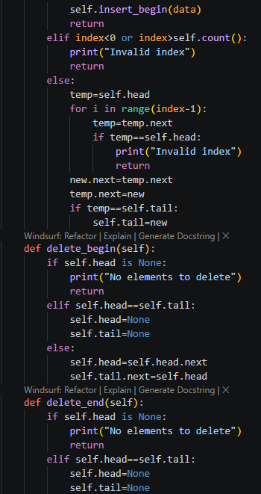
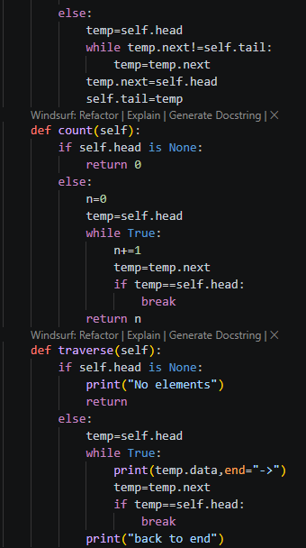
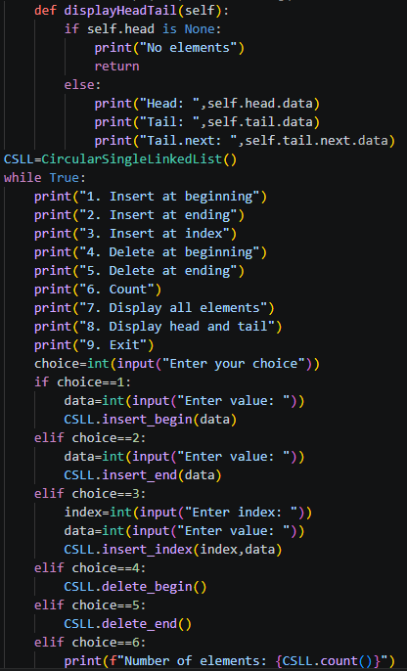
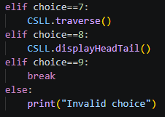
Output:
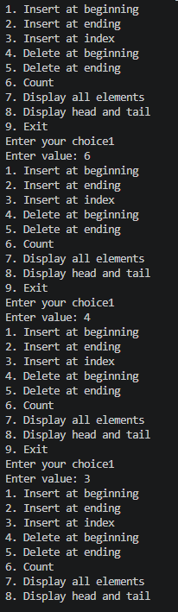
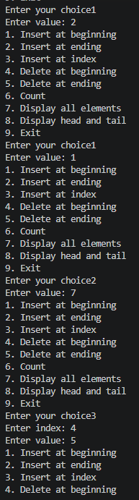
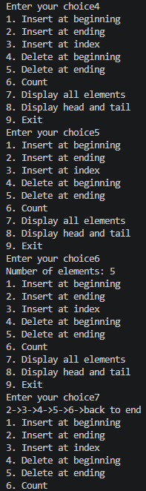
Error Table:
Error | Rectification
No errors
Description:
- The program implements a Circular Linked List using Python classes.
- The Node class is used to create individual nodes.
- Each node contains two parts: data and next.
- data stores the value of the node.
- next stores the reference to the next node.
- In a Circular Linked List, the last node points back to the first node.
- The CircularLinkedList class is used to manage the linked list.
- The head variable stores the reference to the first node.
- The program provides an option to create a circular linked list.
- It supports insertion at the beginning of the list.
- It supports insertion at the end of the list.
- It supports insertion at a specific index.
- It supports deletion of a specific value.
- It supports deletion of the first node.
- It supports deletion of the last node.
- It provides a function to count the number of nodes.
- It provides a function to display/traverse the circular linked list.
- During traversal, the program stops when it reaches the head again.
- The list is displayed using --> and ends with HEAD, showing its circular nature.
- The program handles the special case where the list contains only one node.
- A menu-driven approach is used to perform different CLL operations.
- The program continues until the user selects the Exit option.

Week – 6
6a)
Aim:
Write a Python program to implement stack operations such as Push, Pop, Peek, and Display using an Array.
Code:
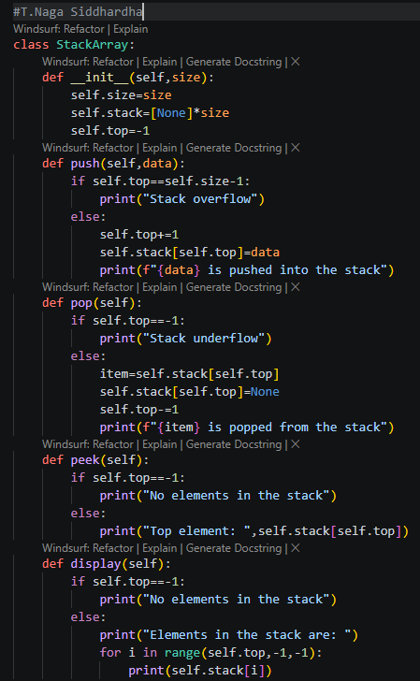
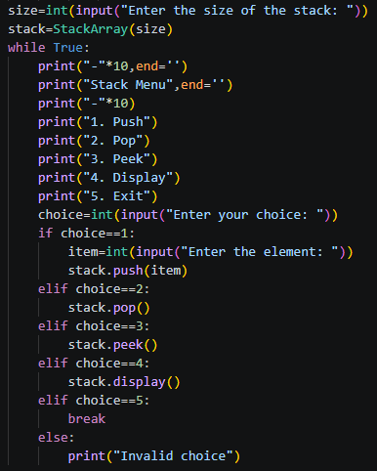
Output:
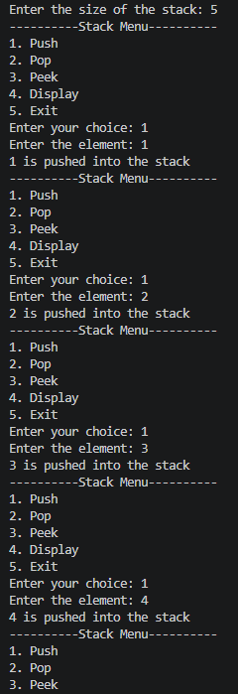
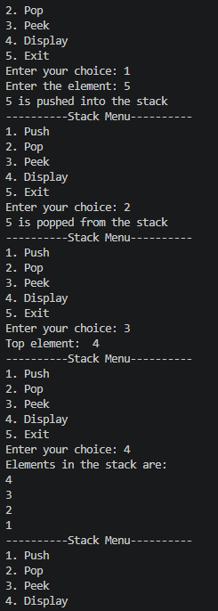
Error Table:
Error | Rectification
In peek, self.peek is taken in ‘if’ does not give correct answer for stack underflow. | Self.top is taken in ‘if’ to give correct output.
Description:
- The Stack class implements a stack using a Python list.
- size stores the maximum size of the stack.
- stack stores the stack elements.
- top keeps track of the top position. Initially, top = -1, meaning the stack is empty.
- Push adds an element to the top of the stack.
- Pop removes the top element from the stack.
- Peek displays the top element without removing it.
- Display prints all elements from top to bottom.
- Stack Overflow occurs when trying to push into a full stack.
- Stack Underflow occurs when trying to pop from an empty stack.
- The program uses a menu-driven approach with options for Push, Pop, Peek, Display, and Exit.

6b)
Aim:
Write a Python program to implement stack operations such as Push, Pop, Peek, and Display using an Linked List
Code:
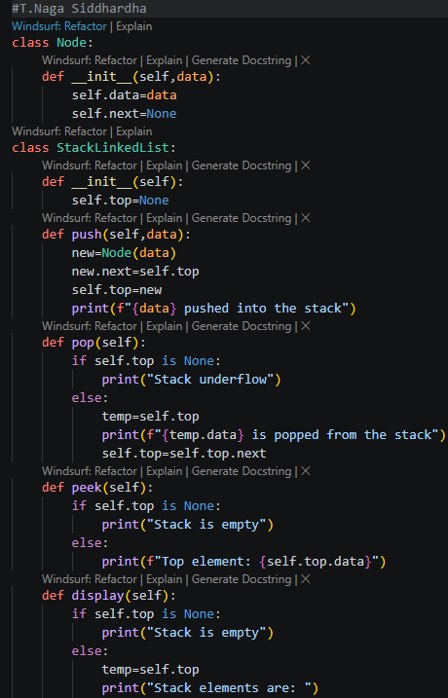
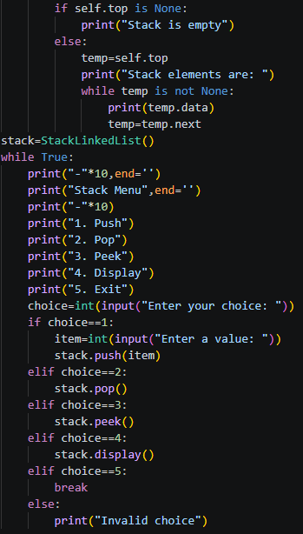
Output:
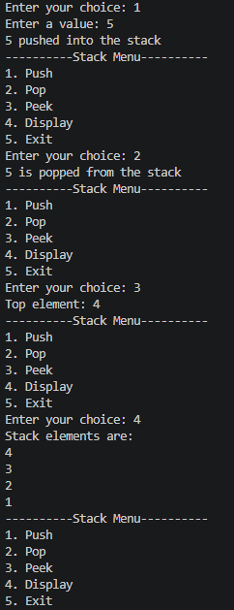
Error Table:
Error | Rectification
No errors
Description:
- The stack is implemented using a singly linked list.
- Each node contains data and a next pointer.
- top points to the top node of the stack.
- Push inserts a new node at the beginning of the linked list.
- Pop removes the node pointed to by top.
- Peek displays the data of the top node without removing it.
- Display traverses the linked list from top to the last node.
- If top is None, the stack is empty.
- Stack Overflow is not a fixed-size issue here because the stack grows dynamically, subject to available memory.

WEEK-7
- Write a Python program to implement a Queue and its operations such as Enqueue, Dequeue, Peek, and Display using a menu-driven approach. Implement the Queue using both an Array and a Linked List data structure.
Input:
Output:
Explanation:
This program implements a FIFO (First In First Out) queue using an array/list in Python with a menu-driven approach. The enqueue operation inserts a new element at the rear of the queue, while the dequeue operation removes an element from the front. The peek operation displays the front element without removing it from the queue. The display operation prints all the elements currently present from front to rear. The program also checks for queue overflow and underflow conditions before performing operations. The menu repeatedly accepts the user's choice and performs the selected operation until the user chooses Exit.
Errors Faced
While implementing the array queue, errors such as Queue Overflow can occur when the rear reaches the maximum queue size, and Queue Underflow can occur when trying to dequeue from an empty queue. Incorrect handling of the front and rear variables can also cause indexing problems or incorrect queue output. Another possible error is ValueError, which occurs when the user enters a non-numeric value where an integer is expected. Invalid menu choices can also cause incorrect operation selection, so an appropriate validation message is displayed.
LINKED LIST:
Input:
Output:
Explanation
This program implements a FIFO queue using a linked list where every element is stored inside a node. Each node contains two parts: data and a reference to the next node. The front pointer points to the first node and the rear pointer points to the last node. During enqueue, a new node is created and attached at the rear, while during dequeue, the front node is removed and the front pointer is moved to the next node. The peek operation displays the data of the front node without deleting it, and display traverses the linked list from front to rear. Since memory is allocated dynamically, the linked-list queue does not require a fixed queue size.
Errors Faced
While implementing the linked-list queue, the main errors faced were related to front and rear pointer management. Queue Underflow can occur when dequeue or peek is performed while the queue is empty. Special care is required when deleting the last element because both front and rear must be changed to None. Incorrectly accessing a node or its next reference may result in an AttributeError. A ValueError may also occur if non-integer data is entered when the program expects an integer. Incorrect pointer updates can also cause elements to be skipped or the linked list to display incorrectly.

b.Write a Python program to implement a Circular Queue and its operations such as Enqueue, Dequeue, Peek, and Display using a menu-driven approach.
Input:
Output:
Explanation:
This program implements a circular queue using an array and follows the FIFO principle. Unlike a normal linear queue, a circular queue allows the rear to move back to the beginning of the array when it reaches the last position. The enqueue operation inserts elements at the rear using the modulo operation, while dequeue removes elements from the front and moves the front circularly. The peek operation displays the current front element without deleting it, and display traverses the queue from front to rear while handling the circular arrangement. The condition (rear + 1) % MAX == front is used to identify a full circular queue, while front == -1 represents an empty queue.
Errors Faced :
While implementing the circular queue, errors can occur if the full and empty conditions are not handled correctly. Circular Queue Overflow occurs when the next position of the rear is equal to the front, while Underflow occurs when the queue is empty. Incorrect use of the modulo operator can cause the front or rear to move to the wrong position. The display operation may also produce an infinite loop if its stopping condition is incorrect, especially when the rear wraps around to the beginning of the array. A ValueError can occur when the user enters invalid non-numeric input, and invalid menu choices must also be handled properly

